Splunk SOC Home Lab – Centralised Log Forwarding & Monitoring

📌 Overview
This project demonstrates a hands-on SOC-style Splunk lab where logs from multiple operating systems are centrally collected, indexed, and analysed. The lab was designed to replicate a real-world Security Operations Centre (SOC) environment, focusing on log ingestion, forwarder management, and data validation.
The environment includes: - A Splunk Enterprise Indexer running on Ubuntu - Universal Forwarders on Kali Linux and Windows Server - Centralised log collection over TCP (port 9997)
This lab highlights my practical experience with SIEM deployment, log forwarding, troubleshooting ingestion issues, and validating security telemetry.

🏗️ Lab Architecture
[Kali Linux] --------┐
├──> [Ubuntu Splunk Enterprise Indexer]
[Windows Server] ----┘ (Port 9997)

Roles
System | Role
Ubuntu Server | Splunk Enterprise (Indexer & Receiver)
Kali Linux | Universal Forwarder
Windows Server | Universal Forwarder

⚙️ Technologies Used
- Splunk Enterprise
- Splunk Universal Forwarder
- Linux (Ubuntu, Kali)
- Windows Server
- TCP Log Forwarding (9997)
- CLI-based Splunk Administration

🚀 Implementation Steps

1️⃣ Splunk Indexer (Ubuntu)
- Installed and configured Splunk Enterprise
- Enabled receiving on TCP port 9997
- Verified listener using netstat
- Configured Splunk to start at boot
Key command:
/opt/splunk/bin/splunk enable listen 9997
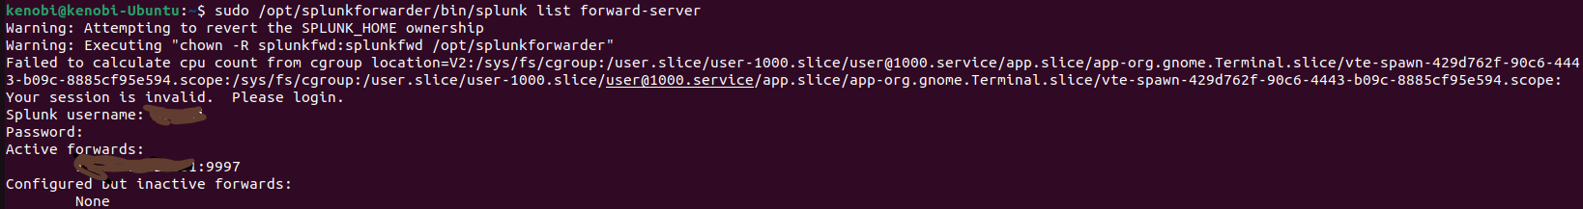
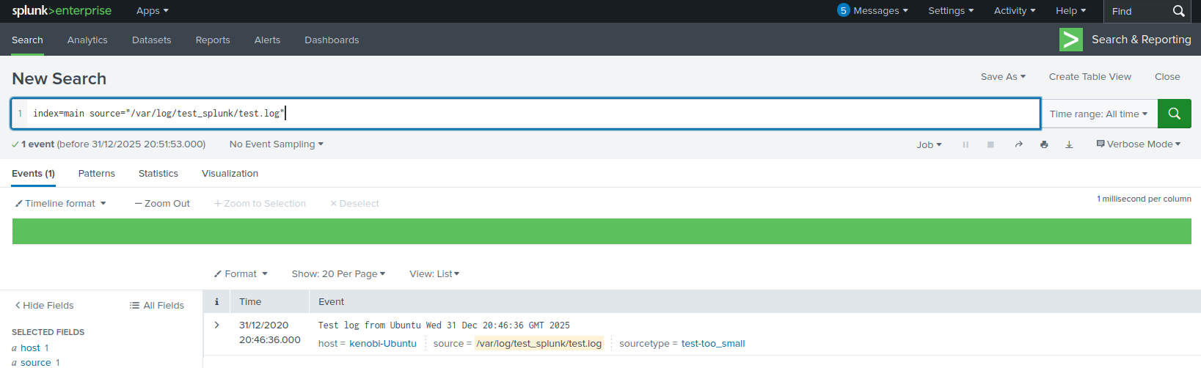

2️⃣ Kali Linux – Universal Forwarder
- Installed Splunk Universal Forwarder using .tgz package
- Created UF admin credentials
- Configured forwarding to Ubuntu indexer
- Monitored /var/log for system logs
Key commands:
splunk add forward-server <Indexer_IP>:9997
splunk add monitor /var/log
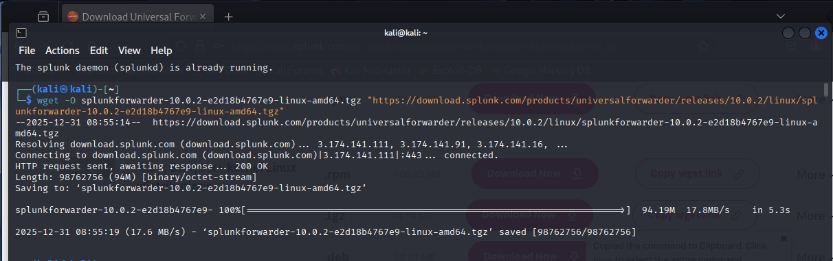
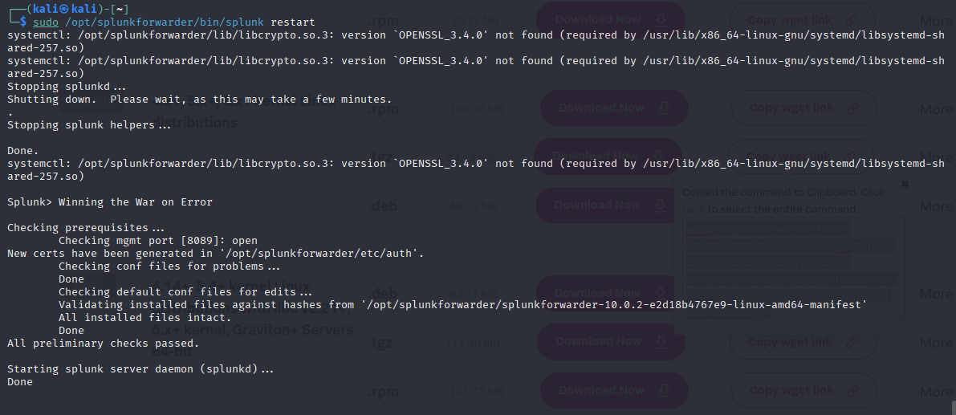
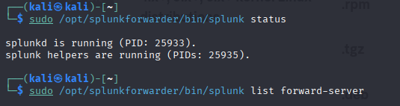

3️⃣ Windows Server – Universal Forwarder
- Installed Universal Forwarder (MSI)
- Configured forwarding to the same indexer
- Monitored Windows Event Logs and system directories

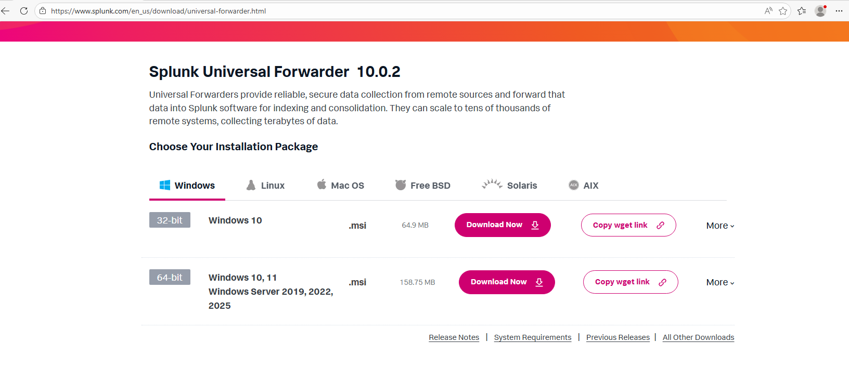

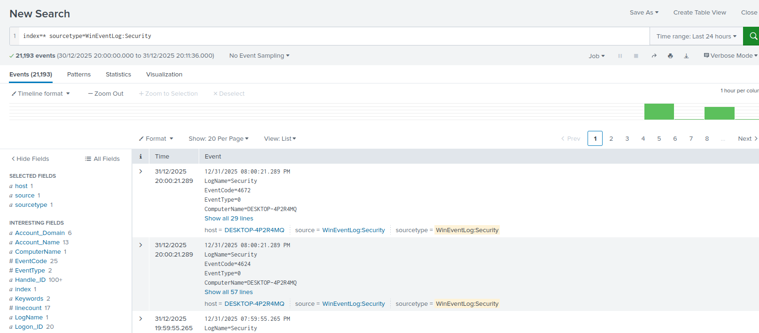

🔍 Validation & Testing
To confirm successful ingestion: - Generated test logs on Kali Linux - Verified logs appeared in Splunk Search - Confirmed correct metadata: - Host - Source - Sourcetype
Example indexed event: - Host: kali - Source: /var/log/test_splunk.log - Indexed in near real-time
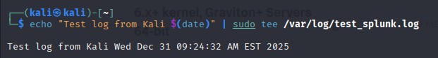
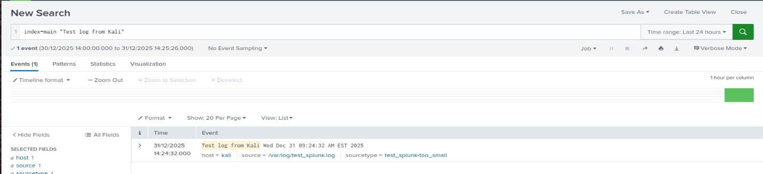

🛠️ Troubleshooting Performed
During setup, several real-world issues were encountered and resolved: - Permission errors with Splunk directories - Forwarder session authentication issues - Port connectivity validation - Differentiating forwarder vs indexer CLI behaviour
This reinforced a strong understanding of Splunk architecture and operational troubleshooting.

📊 Skills Demonstrated
- SIEM deployment and configuration
- Log forwarding architecture
- Linux & Windows administration
- Network troubleshooting
- Security monitoring fundamentals
- SOC workflow understanding

📈 Next Enhancements
- Create separate indexes per host
- Add Windows Security Event Log monitoring
- Build SOC dashboards (failed logins, sudo activity)
- Integrate threat intelligence feeds
- Document detections and alerts

🧠 Key Takeaway
This lab demonstrates my ability to design, deploy, and validate a working SIEM environment, mirroring tasks expected of a SOC Analyst in production environments.

📂 This project is part of my ongoing SOC home lab and continuous professional development in cybersecurity.

